Exercise 17

- Find and list the ids and spouse names of all employees wjo are married.
SELECT e_id, s_name FROM employee_per WHERE m_status = 'Y';
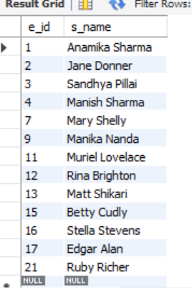
- Change the above so that the display is sorted on spouse names.
SELECT e_id, s_name FROM employee_per WHERE m_status = 'Y' ORDER BY s_name ASC;
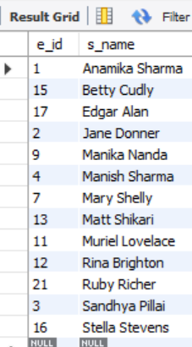
- How many employees do we have under each sex (male and female) ?
SELECT sex, COUNT(*) AS num_employees FROM employee_per GROUP BY sex;
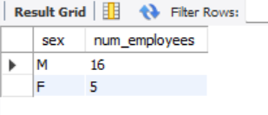
- How many of our employees are married and unmarried?
SELECT m_status AS marital_status, COUNT(*) AS num_employees FROM employee_per GROUP BY m_status;
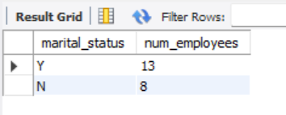
- Find the total number of children.
SELECT SUM(children) AS total_children FROM employee_per;
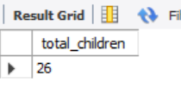
- Make unique groups of children and find the number in each group. Sort the display with the group having maximum children, at the top
SELECT IFNULL(children,0) AS children, COUNT(*) AS num_employees FROM employee_per GROUP BY IFNULL(children,0) ORDER BY num_employees DESC;.
